IN THE NAME OF ALLAH

Microsoft Azure Blockchain

In this article we discussed about azure blockchain platform by these topics:

.An introduction to azure blockchain service

.Advantages of Azure than other services

.Projects which developed in azure and their main problems which tend them to blockchain solution

As you may be familiar with Microsoft Azure it is actually a cloud wich different parts and abilities which give to you. One of it’s products is Azure blockchain service.

Azure blockchain service is a consortium blockchain platform which is provided by Microsoft and it’s partners; EY , Accenture & Consensys .

For the first feature and actually the most important one in my opinion of azure is that ” It is a very UI based platform”. In fact one of microsoft’s purpose of it’s platform is being very user friendly than other blockchains which exist. For example it claimed that one of the annoying problems in a simple blockchain is to save a long no-meaning hash number as your identiy but that would be easier to work if we can create account by just our email or something else which could have the same security as that hash number.

It release a solution for it that is based on a part called DIF Identity Hubs . in simple word microsoft works with that complex number with it’s HUB and you just work with email and such things like that.

(the whole solution of that is [here](Microsoft%20Decentralized%20Identity.pdf)). By thinking of that at first we wonder that Microsoft has all our accounts and can do what ever it like! But in their article they claimed that Identity Hub doesn’t save accounts and just work with them( actually like a smart contract which the code just do what it’s function wants ). But at last by seeing other features like identity you’ll understand it is a distributed ledger in a centralized platform, so they **do** have access to some data.

The next feature of azure is that “it is fast”. You can transfer messages after you build a contract to see that it would take a second the complete it .

So let’s talk about it’s main part of that. Actually when you create account and get in (that’s not so easy at last if you are in a country which is in sanctions that can not send your phone number to be verified! Or even your credit card .) then you have two choices . you can connect to an existing blockchain a do what you like ( like any other platforms ) or you can build a new blockchain for example with ten nodes wich you can set their accesses and levels . Actually in this platform you will connect to ethereum , hyperledger or corda in a Microsoft cloud environment.

Another point is that you don’t have to use azure virtual machine to build and run your codes ; you can actually use others like remix , etc in azure blockchain . and like that for front-end you can use apps like ganache to see your blockchain !

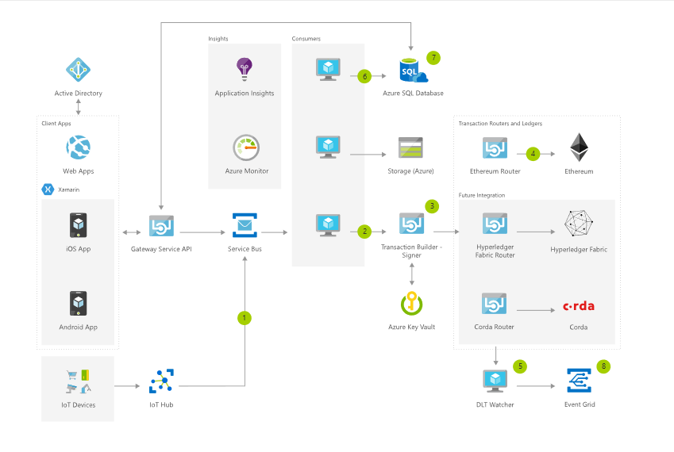

This was an introduction to what azure blockchain is and what features does it have. So now you should decide is it fit on you or not? So let’s see what are real projects which has build on it and what was their main problem that lend them to blockchain ?

*.* ***Insurwave* :** EY and Guardtime in collaboration with other insurance industry leaders claimed that present the first insurance company which use blockchain for their work.

Az all industries came up to date with digital age , insurance companies still work with traditional papers , stamps etc while they can save lots of money , energy and time by digitalizing the process.

The EY Insurance Advisory Practice has been experimenting with using blockchain technology to modernize and transform the industries it serves and felt that marine insurance was a perfect candidate for a blockchain ledger solution. “The structural complexity of specialty insurance makes it ideal for blockchain,” Schrijnen says. “A shared, distributed ledger lends itself to this need for exchanging transparent, trustworthy data in a standard format in real time.”

In early 2017, EY got together with network security expert Guardtime and set out to build a prototype of a blockchain solution. They aimed to enable marine insurance brokers, insurers, and their clients to receive real-time data from the assets they covered to better price risk and facilitate faster claims processing.

. EY – providing overall coordination and network operations

. Guardtime – providing blockchain software development

. Willis Towers Watson – digitally transforming the role of the insurance broker

. XL Catlin – digitally transforming the role of the insurer

. MS Amlin – digitally transforming the role of the reinsurer

. A.P. Moller - Maersk – digitally transforming the role of the risk manager and providing a live use case of the solution

. R3 – provider of Corda blockchain platform

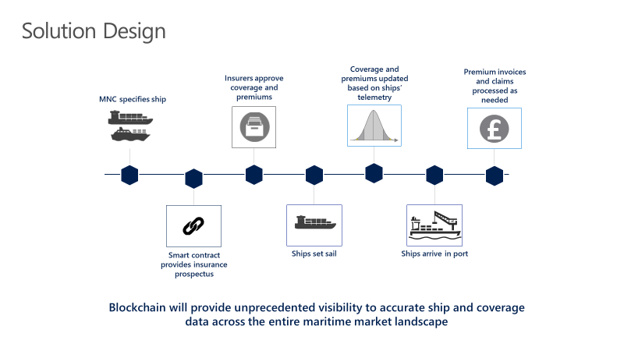

**. *Xbox* :** When Microsoft deployed a blockchain-based solution to offer royalty information to Xbox game publishers in near real time, it dramatically lowered statement access times from 45 days to just minutes

Actually it take a much finance for game publishers so it tend them to create xbox token! This solution is interesting for gamers too and in fact is more than a game.

. ***Ubin project* :** Microsoft has announced its collaboration with the Monetary Authority of Singapore (MAS) and The Association of Banks in Singapore (ABS) to support Project Ubin Phase 2. Led by MAS and ABS, Project Ubin is a strategic industry wide project to explore the use of Distributed Ledger Technology (DLT) for the clearing and settlement of payments and securities, and a key milestone in Singapore’s ambition of becoming a Smart Financial Centre.

Phase 1 of Project Ubin was announced in November 2016 where MAS partnered with R3 and banks on a proof of concept for digital domestic currency. This initial phase successfully proved the use of a tokenized form of the Singapore Dollar (digital dSGD) with distributed ledger technology (DLT). Phase 2 extends the development onto three DLT platforms and addresses issues identified in Phase 1 around transaction finality and privacy, and the development of liquidity savings mechanisms. Participating financial institutions include Bank of America Merrill Lynch, Citi, Credit Suisse, DBS Bank Ltd, HSBC Limited, J.P. Morgan, Mitsubishi UFJ Financial Group, OCBC Bank, Singapore Exchange, Standard Chartered Bank, and United Overseas Bank.

# . *Webjet* : The hotel booking ecosystem is complex, decentralized, and high volume, with millions of transactions per day. To streamline processes and reduce industry-wide costs, Webjet uses blockchain to power Rezchain, a data reconciliation service for the travel industry. With Rezchain, the company has seen a 90 percent reduction in losses associated with transaction disputes across its internal brands. And as more external partners join the Rezchain network, Webjet can extend those efficiencies throughout the industry.

**Rezchain** is the hotel distribution industry’s first functioning blockchain enabled technology platform allowing companies to share booking data “on the chain” in order to address mismatched information in real time. This ground breaking new technology not only eliminates disputes at invoice time but plays a key role in:

* Reducing errors
* Preventing issues “at the hotel”
* Avoiding losses from occurring
* Saving countless hours of staff time spent reconciling bookings
* Protecting key relationships between buying and selling partners
* Reducing errors, preventing losses, saving countless labour hours

There are actually other projects which are available to read about in [azure blockchain website](https://azure.microsoft.com/en-us/solutions/blockchain/).

# Pouria Dadkhah